Mašininio mokymosi modeliai

Atliko: Mantas Dzimidas

1. Paruošto mokymui dataframe Heatmap

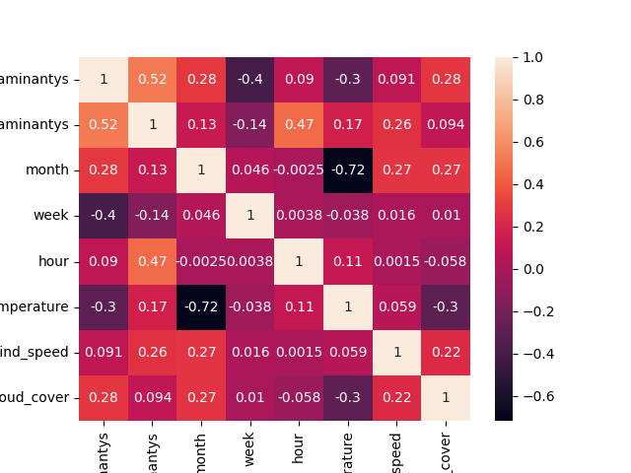

1. Paruošto mokymui dataframe Pairplot

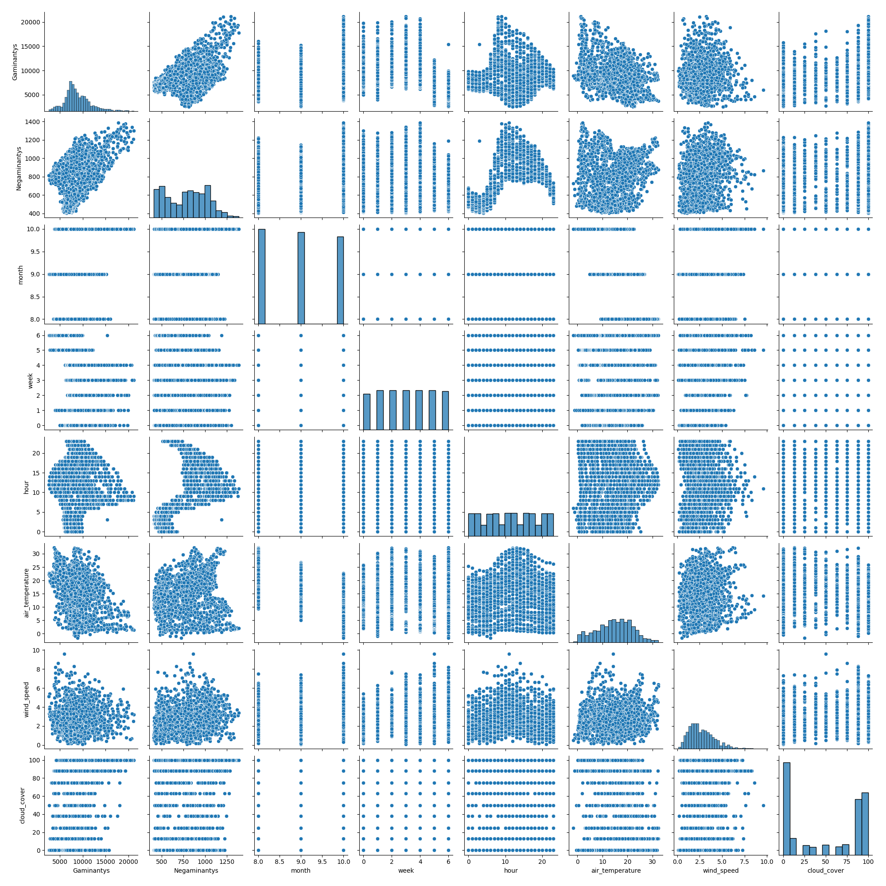

1. Modelių rezultatai

Gaminančių vartotojų Decision tree vertinimas:   
 Fit score: 74.7315865448359   
 R2 score: 74.7315865448359   
 Root Mean Squared Error: 1486.347155476298   
 Mean Absolute Error : 900.3423658175436

Negaminančių vartotojų Decision tree vertinimas:   
 Fit score: -138390.3938116079   
 R2 score: 94.77850936069765   
 Root Mean Squared Error: 53.98842257782356   
 Mean Absolute Error : 38.64886902747375

Gaminančių vartotojų SVM linear:   
 Fit score: 100.0   
 R2 score: 26.77933276966149   
 Root Mean Squared Error: 2530.1607258848617   
 Mean Absolute Error : 1770.6635419516883

Negaminančių vartotojų SVM linear:   
 Fit score: 100.0   
 R2 score: -110033.53355591808   
 Root Mean Squared Error: 7840.85050110539   
 Mean Absolute Error : 7744.869919833693

Gaminančių vartotojų SVM linear:   
 Fit score: 100.0   
 R2 score: 4.777562381612322   
 Root Mean Squared Error: 2885.366043926833   
 Mean Absolute Error : 2074.073946732593

Negaminančių vartotojų SVM linear:   
 Fit score: 100.0   
 R2 score: -103407.96178708367   
 Root Mean Squared Error: 7601.341864958621   
 Mean Absolute Error : 7584.198323010894

Gaminančių vartotojų SVM linear:   
 Fit score: 100.0   
 R2 score: 4.777562381612322   
 Root Mean Squared Error: 2885.366043926833   
 Mean Absolute Error : 2074.073946732593

Negaminančių vartotojų SVM linear:   
 Fit score: 100.0   
 R2 score: -103407.96178708367   
 Root Mean Squared Error: 7601.341864958621   
 Mean Absolute Error : 7584.198323010894

Gaminančių vartotojų Random forest vertinimas:   
 Fit score: 88.97542854694086   
 R2 score: 88.97542854694086   
 Root Mean Squared Error: 981.7753580974642   
 Mean Absolute Error : 626.0512910369943

Negaminančių vartotojų Random forest vertinimas:   
 Fit score: 97.35175902049828   
 R2 score: 97.35175902049828   
 Root Mean Squared Error: 38.448742242298394   
 Mean Absolute Error : 27.844259098462555

Gaminančių vartotojų linijinės vertinimas:   
 Fit score: 30.573025488301553   
 R2 score: 30.573025488301553   
 Root Mean Squared Error: 2463.742919069633   
 Mean Absolute Error : 1817.7504003374847

Negaminančių vartotojų linijinės vertinimas:   
 Fit score: 36.48219540059604   
 R2 score: 36.48219540059604   
 Root Mean Squared Error: 188.30034950316357   
 Mean Absolute Error : 147.66570231105135

1. Modelių apmokymas

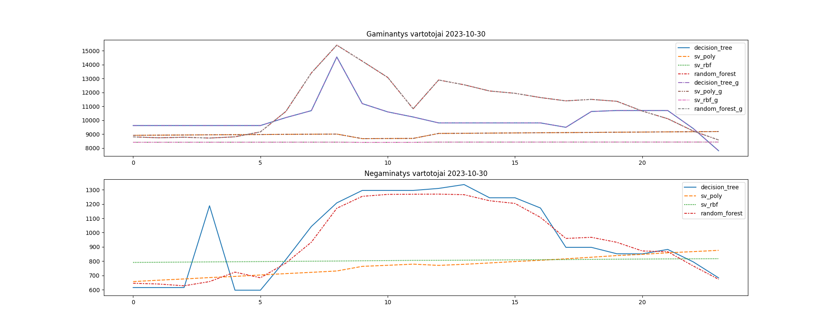

1. Modelių lyginimas su Nordpool

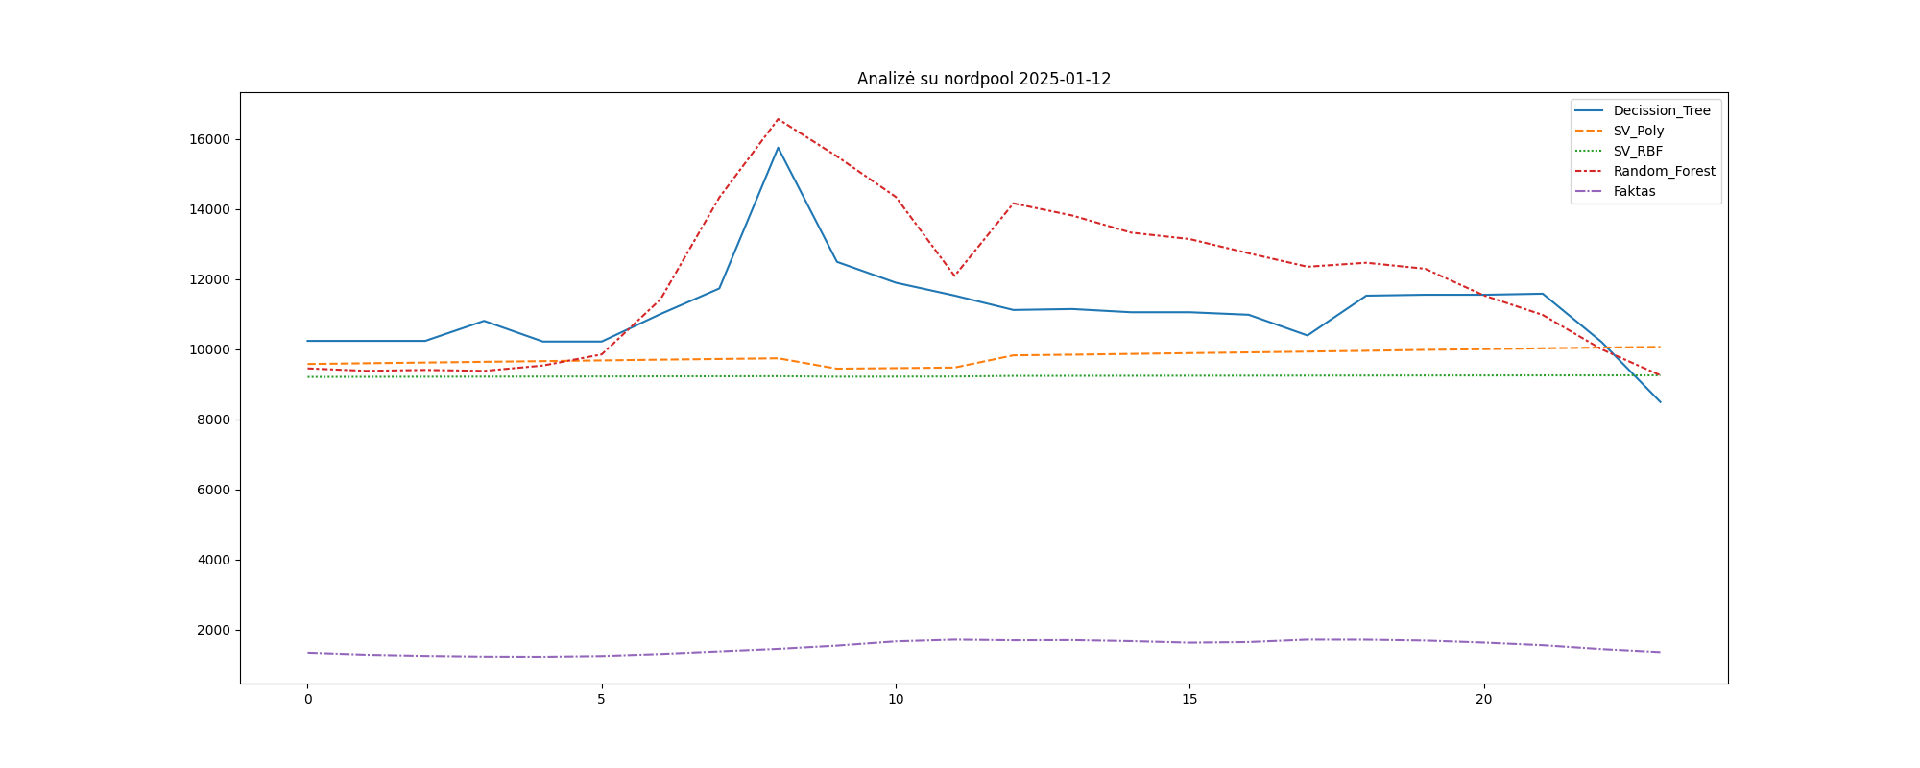

1. Rezultatai

|  |  |  |  |  |  |
| --- | --- | --- | --- | --- | --- |
| datetime | Decission_Tree | SV_Poly | SV_RBF | Random_Forest | Faktas |
| 2025-01-12 00:00:00 | 10233.069372999997 | 9573.333767999671 | 9205.15432098401 | 9448.296531754913 | 1332.3 |
| 2025-01-12 01:00:00 | 10233.069372999997 | 9595.102962818428 | 9207.795683294056 | 9377.429182082014 | 1274.8 |
| 2025-01-12 02:00:00 | 10233.069372999997 | 9614.698156545912 | 9210.253367913581 | 9403.677914631227 | 1243.3 |
| 2025-01-12 03:00:00 | 10804.784702999996 | 9635.915523726095 | 9212.812939619456 | 9376.383073269792 | 1223.8 |
| 2025-01-12 04:00:00 | 10214.65473315528 | 9655.328534915716 | 9215.025536436837 | 9529.826389867632 | 1219.3 |
| 2025-01-12 05:00:00 | 10214.65473315528 | 9676.296717626592 | 9217.586407226905 | 9846.94349385478 | 1239.5 |
| 2025-01-12 06:00:00 | 11000.217487000007 | 9697.685792754372 | 9219.999951289508 | 11418.878360003546 | 1295.0 |
| 2025-01-12 07:00:00 | 11730.275086999996 | 9716.544763120703 | 9222.237436065063 | 14326.9770348728 | 1368.0 |
| 2025-01-12 08:00:00 | 15750.04462101245 | 9736.762093412643 | 9224.541781501564 | 16565.85076290955 | 1439.5 |
| 2025-01-12 09:00:00 | 12488.746351999996 | 9439.802561062957 | 9211.218860589597 | 15500.382847549823 | 1532.0 |
| 2025-01-12 10:00:00 | 11894.074632000003 | 9455.63884925429 | 9213.540384233896 | 14343.580548741467 | 1652.0 |
| 2025-01-12 11:00:00 | 11526.844600999993 | 9472.34481358437 | 9215.96240846839 | 12087.162107898632 | 1701.3 |
| 2025-01-12 12:00:00 | 11116.228800969251 | 9820.9676198939 | 9233.22433658297 | 14159.483870635959 | 1683.3 |
| 2025-01-12 13:00:00 | 11143.19367009892 | 9839.350547355167 | 9234.625197458083 | 13812.167692976325 | 1687.8 |
| 2025-01-12 14:00:00 | 11050.963392003463 | 9862.112473639658 | 9236.373717151306 | 13324.259538710638 | 1658.3 |
| 2025-01-12 15:00:00 | 11050.963392003463 | 9884.959467159311 | 9238.099875285654 | 13138.62497470875 | 1614.8 |
| 2025-01-12 16:00:00 | 10979.451430026471 | 9905.809670111168 | 9239.518146620767 | 12735.005202373055 | 1632.0 |
| 2025-01-12 17:00:00 | 10387.576198000002 | 9927.898969639016 | 9241.196811537518 | 12349.604613435748 | 1700.8 |
| 2025-01-12 18:00:00 | 11523.93294704931 | 9951.240472549875 | 9243.02522682574 | 12463.526058703996 | 1698.8 |
| 2025-01-12 19:00:00 | 11549.7518926028 | 9977.17834868044 | 9244.601943247822 | 12292.515223285342 | 1675.0 |
| 2025-01-12 20:00:00 | 11549.045894602801 | 9996.915829369918 | 9245.66297083513 | 11530.172699632325 | 1617.5 |
| 2025-01-12 21:00:00 | 11579.995783601846 | 10021.952301574851 | 9246.93042857562 | 10974.571832071024 | 1543.8 |
| 2025-01-12 22:00:00 | 10202.997406023482 | 10041.928411408031 | 9247.667339242922 | 9994.641788568211 | 1432.5 |
| 2025-01-12 23:00:00 | 8489.045207985691 | 10062.216612748281 | 9248.505398396397 | 9251.811108919825 | 1347.0 |